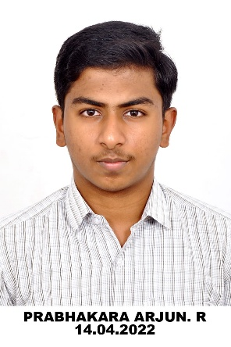

R.PRABHAKARA ARJUN

## **Envelope Ambitious and Self Motivated Computer Engineering Undergraduate**

 [arjunprabhakar1910@gmail.com](mailto:arjunprabhakar1910@gmail.com) 9445462959 [themysterysolver](https://github.com/themysterysolver)  [Prabha](https://www.linkedin.com/in/prabhakara-arjun/)

A passionate computer science and engineering student interested in **problem solving,programming** and **web development.** I have a strong ability to learn new skills and a motivation to seek creative solutions. I possess **strong communication** and **teamwork** abilities, demonstrated through excellent **presentation skills**, **active listening**, and success in **cross-functional, team-oriented** environments.

#### B. E. Computer Science and Engineering Anna University, MIT campus

Nov 2022 - Present

CGPA:8.64

## EDUCATION

#### DAV Boys senior secondary School, Gopalapuram

June2020 – June2022

HSC Boards: 93.4%

SKILLS:

**Soft-skills:**

* Teamwork and Collaboration
* Effective Communication
* Active Listening
* **Problem-solving abilities**
* **Object-Oriented Programming**
* **Web application development**
* *Programming / Tech*: C, Java, Python, JavaScript, Shell, MySQL, SQL
* *Platforms:* GitHub,Canva,wordpress

AREA OF INTRESTS:

Logical Thinking

Machine Learning

Data structures and algorithm

Problem Solving

Web development

Object oriented programming

Mathematics and aptitude

LANGUAGE: PROJECTS:

**Tamil**-Full professional proficiency PHISHING-EMAIL DETECTION

**English**-Full professional proficiency TIC-TAC-TOE BOT

**Hindi**-Basic proficiency CAR PARKING MANAGEMENT

CERTIFICATION: PROFILES:

HTML-CSS-JAVASCRIPT-coursera **LEETCODE:** [*https://leetcode.com/u/arjunprabhakar1910/*](https://leetcode.com/u/arjunprabhakar1910/)

PROGRAMMING IN JAVA-NPTEL **HACKER RANK:** [*https://www.hackerrank.com/profile/arjunprabhakar19*](https://www.hackerrank.com/profile/arjunprabhakar19)

HOBBY:

**Chess**: "Playing chess enhances my problem-solving abilities and improves my presence of mind."

**Debate**: "Participating in debates strengthens my communication skills and enhances my verbal proficiency."